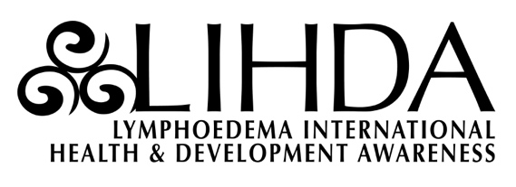

Recycle supplies. Show your pride.

Thank you for showing interest in LIHDA’s garment recycling program.

By donating out of date compression garments you are directly improving the quality of life of many people. Firstly, your giving comfort to patients in developing countries without the means to purchase garments otherwise. You’re also equipping their practitioners with the tools to offer better care for their patients. As well, you are giving a second life to medical supplies and that is good for everyone.

Here is how you can join us and start something great in your clinic:

- Set up a recycling bin in a location that is central to garment activity and where you and your colleagues can easily deposit out of date garments destined for a landfill.

- Visit lihda.org and read all about us. The new PDF files will be added shortly at the bottom of the Contact page. Download and print the three files ⎯ box sticker and poster.

- Cut the box sticker in two and attach on either side of your bin (ideally printed on sticker paper) where it can easily be seen to encourage colleagues to take part.

- Hang the poster in prominent places where patients can learn about the program and how to contribute.

- Once your box is full, email us at lihdainfo@gmail.com and we will provide you with our shipping address here in the UK. We are actively searching for a delivery service willing to cover shipping costs within the UK, and by the time your bin is full we hope to make it that much easier and cost-effective to get them to us.

We’ll send you updates on your donation’s wonderful story to share with colleagues and patients and we’ll reward you with certificates along the way. Hang them in your waiting room to celebrate the good you have done!

Thank you for taking the time, energy and patience to coordinate this effort in your facility. Once it’s up and running it takes very little of your time to do a world of good!

